## **Assembled Guide**

Check the board A~I and parts firstly

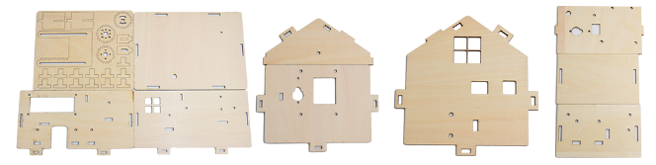

**Step 1: Install sensors of A board**

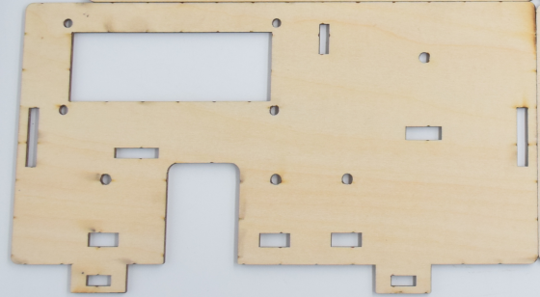

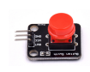X2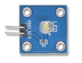X1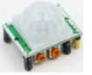X1

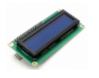X1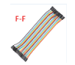x12

M3x10screws Quantity :7

M3Nut Quantity :7

M2X22screws Quantity :1

M2Nut Quantity :2

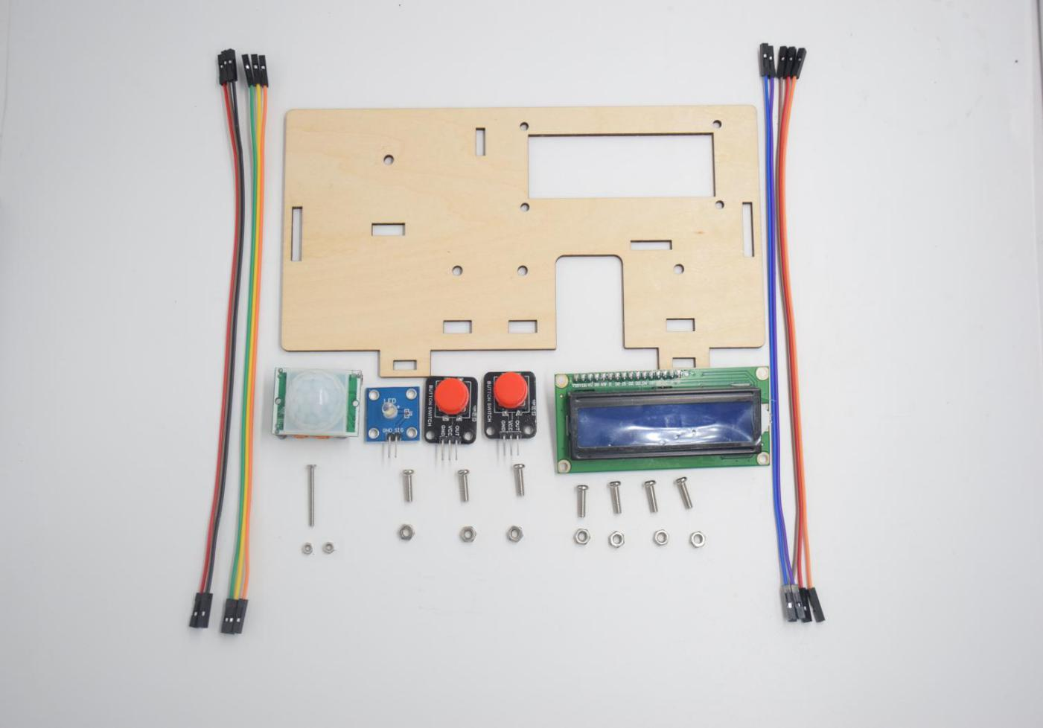

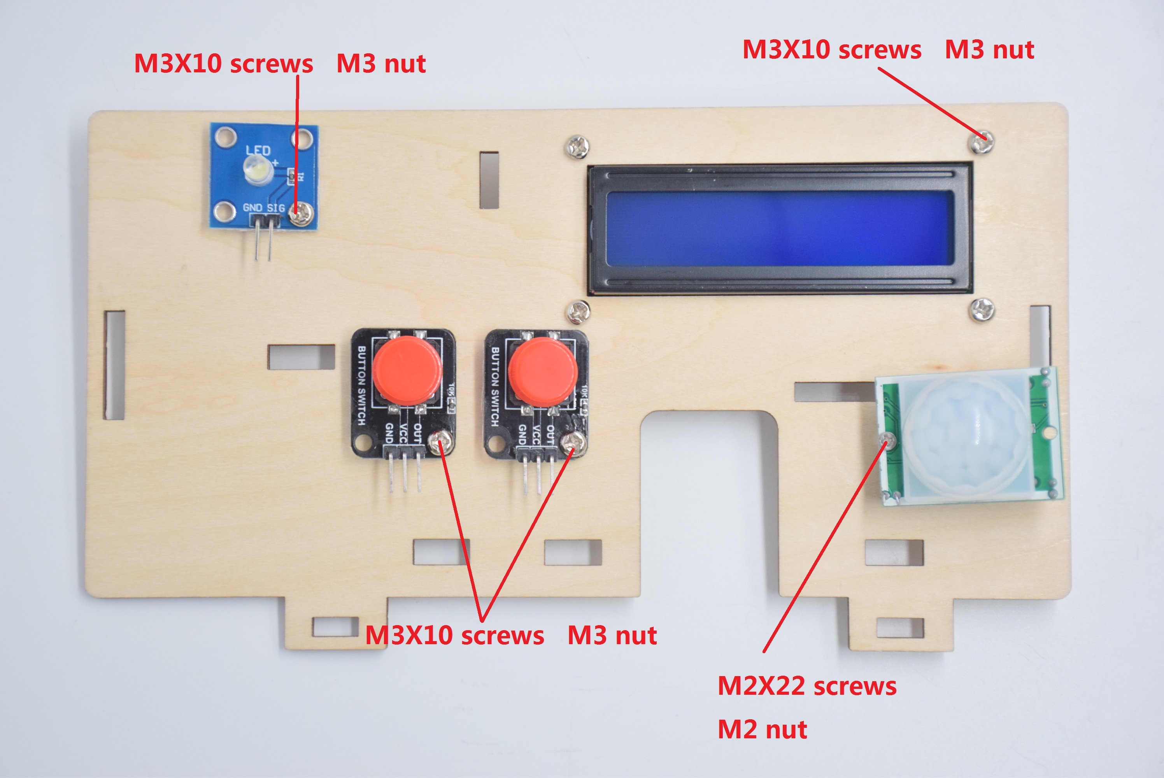

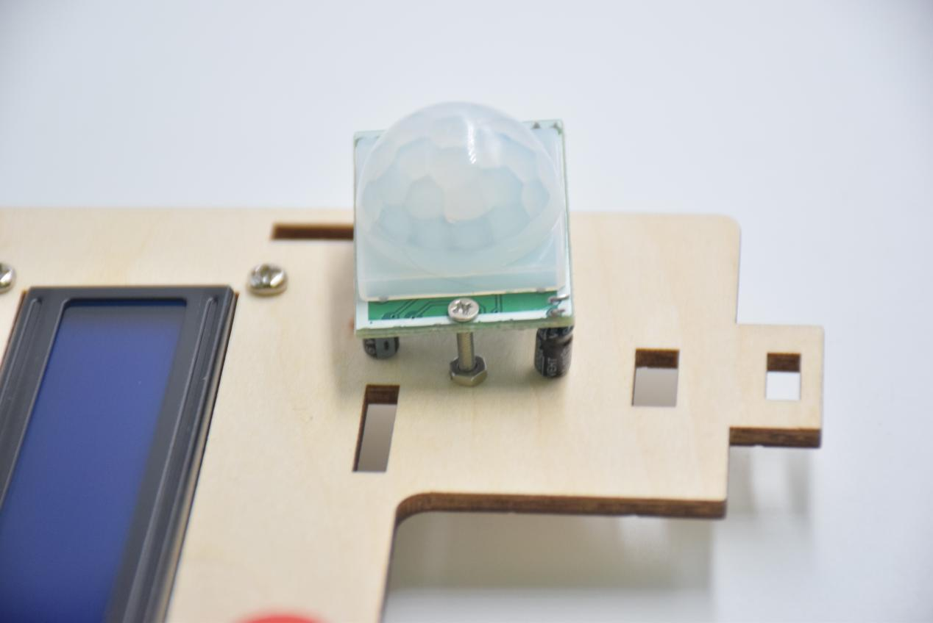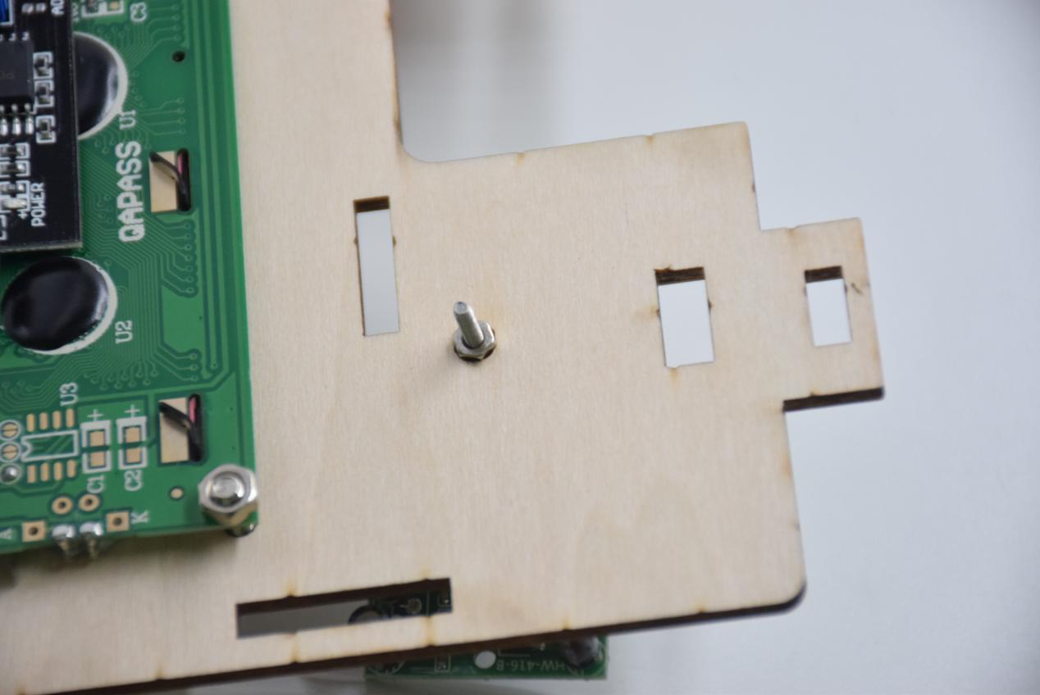

**Step 2: Install the sensor of B board**

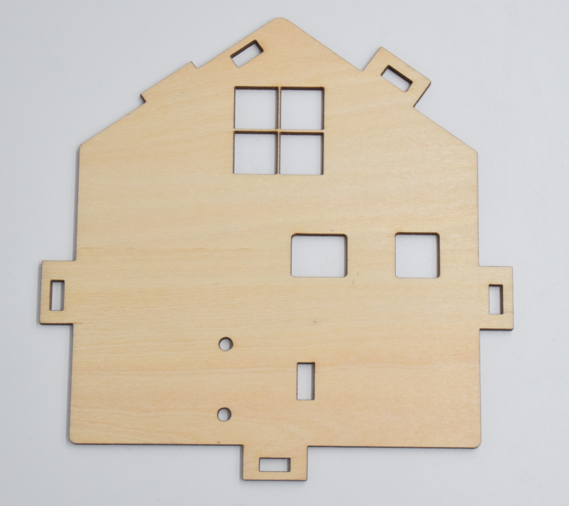

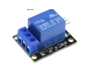x1x3

M3x10screws Quantity :2

M3Nut Quantity :2

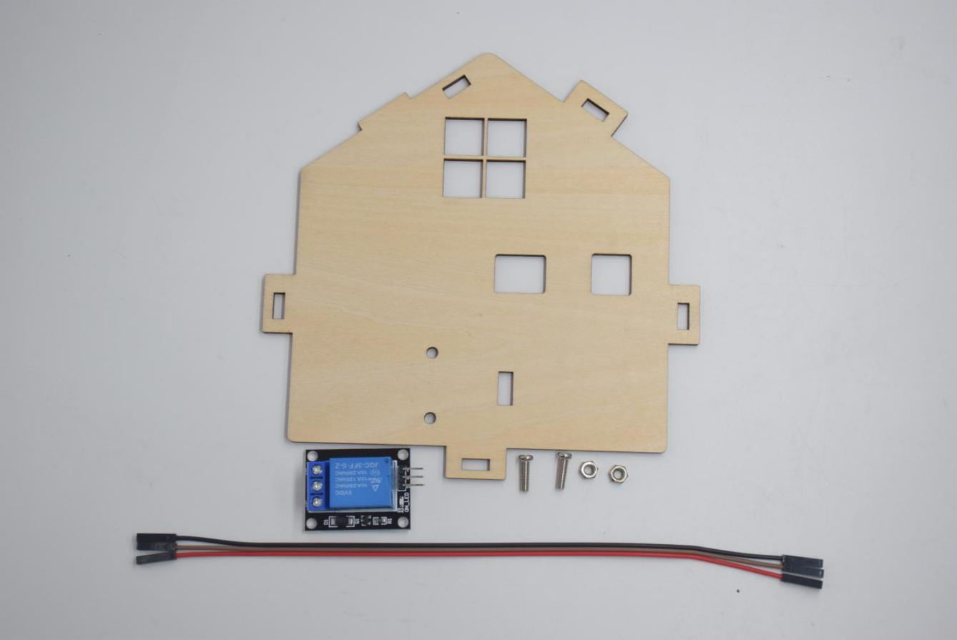

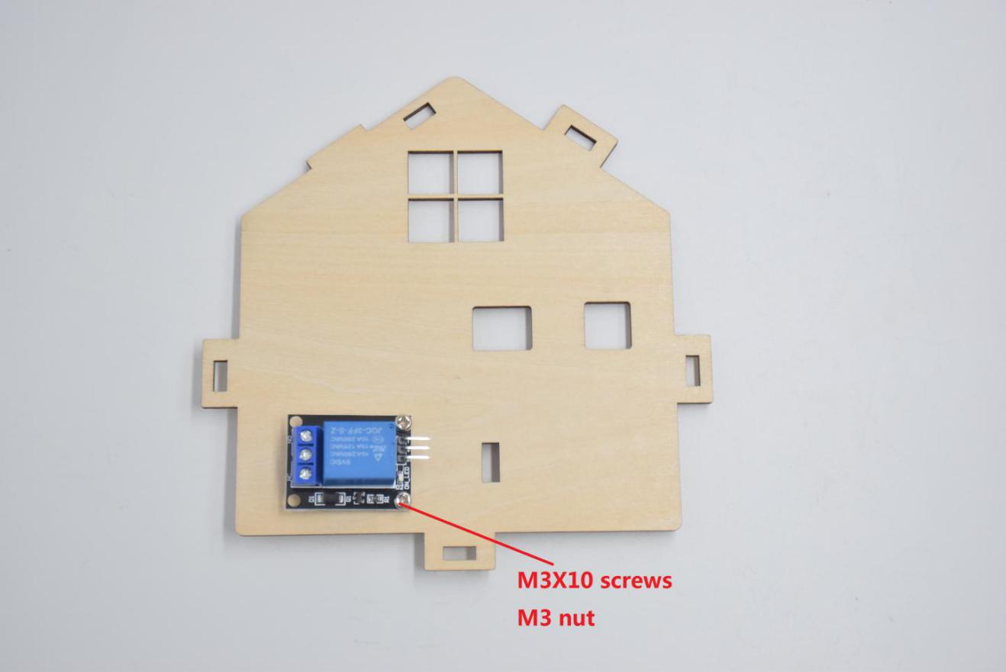

**Step 3: Assemble the sensors and battery holder of C board**

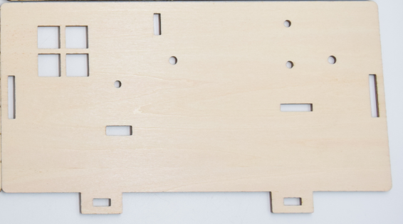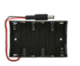

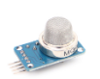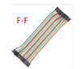X3

M3X10 screw quantity: 2

M3X7 screw quantity: 2

M3 Copper Pillar Quantity: 1

M3nutquantity:2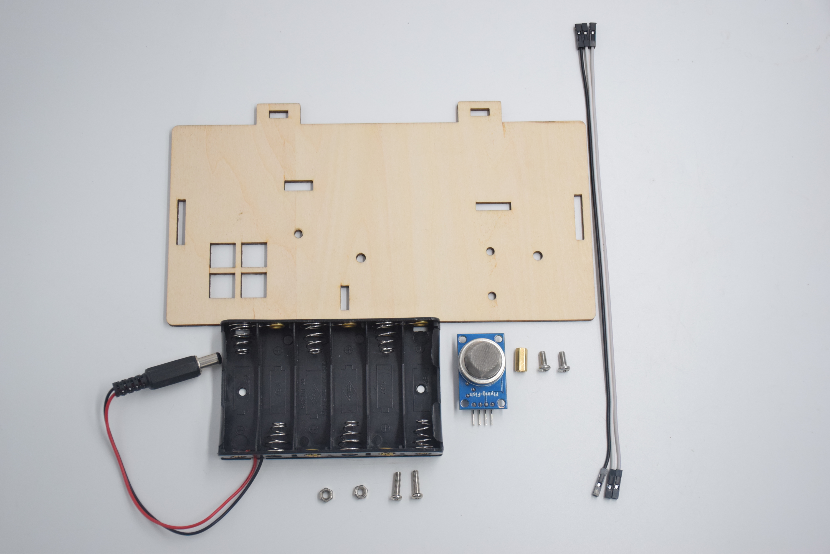

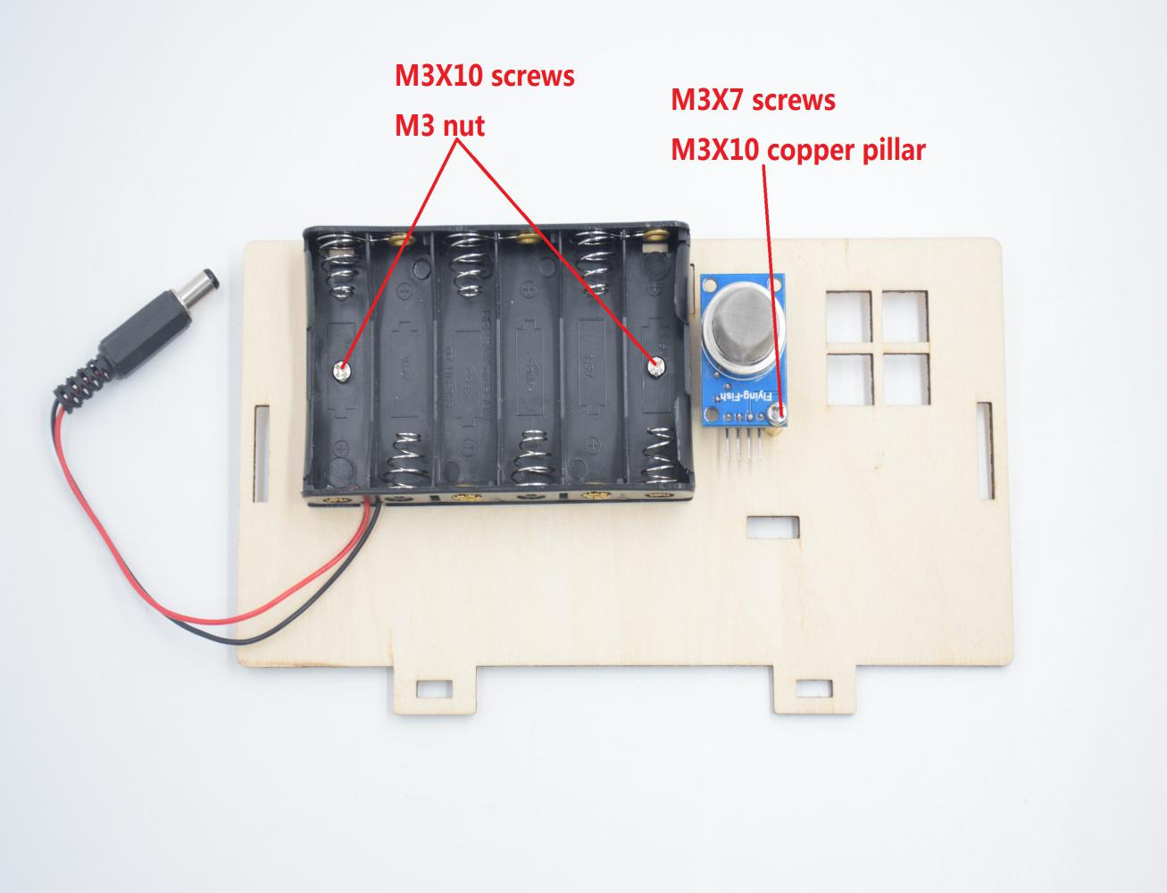

**Step 4: Install the sensors and parts of D board**

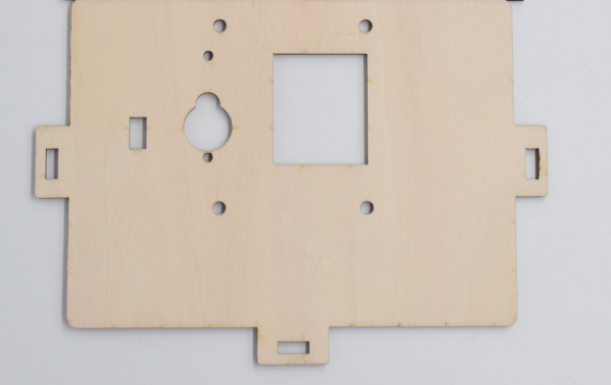x1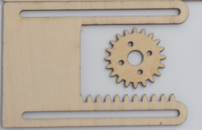x1

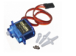x1

M3X10 Screw Quantity: 4

M2X12 screw quantity: 2

M2 nut quantity: 2

M1.2X5 self-tapping screws Quantity: 4

The number of M2X5 in the steering gear bag: 1

M3 Copper Pillar Quantity: 1

M3 anti-falling nut Quantity: 4

Fan blades in the steering gear bag quantity 1

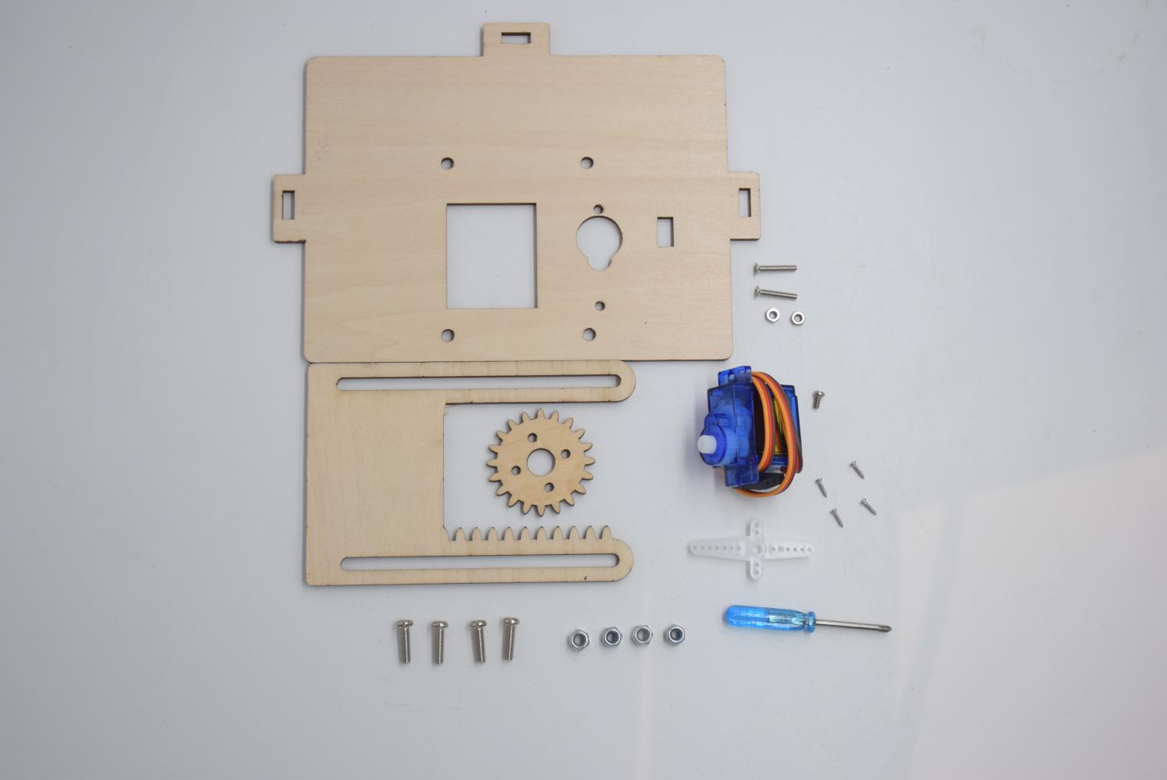

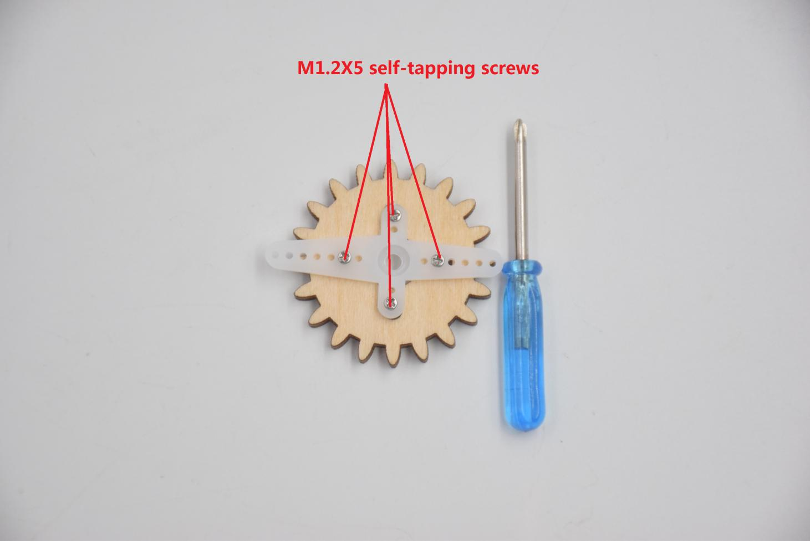

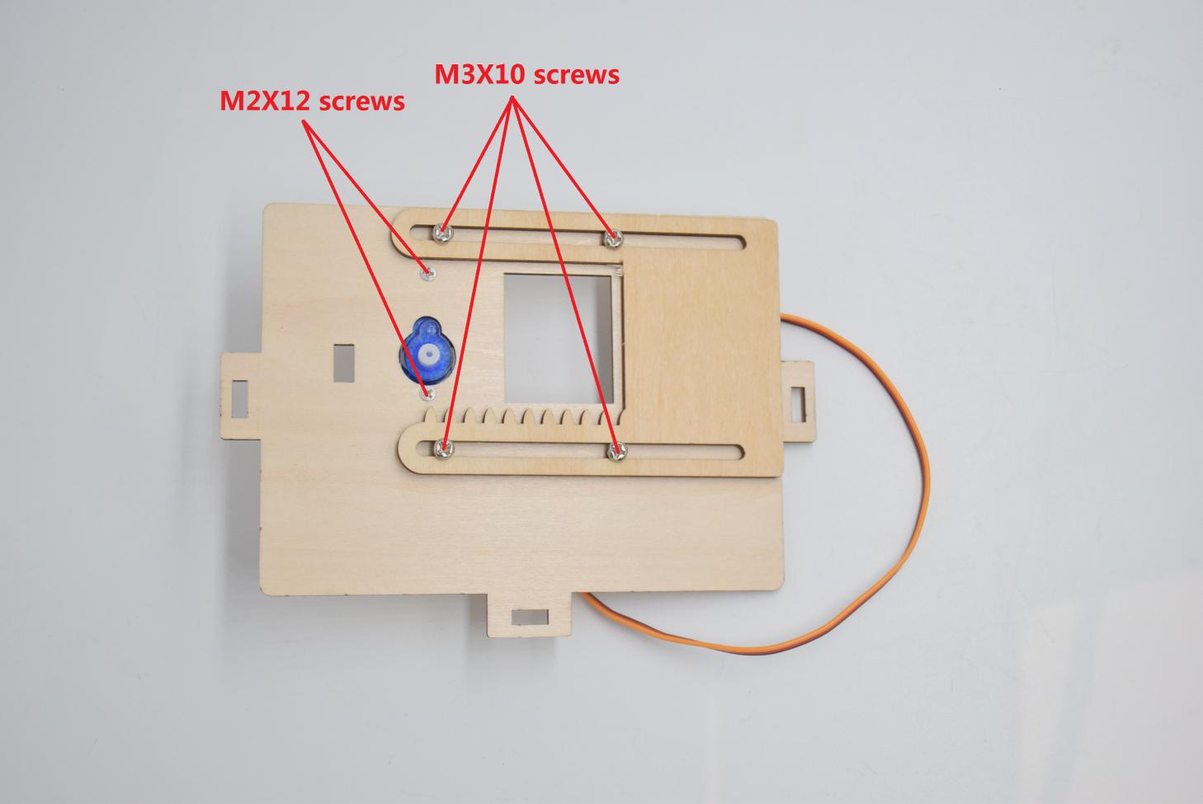

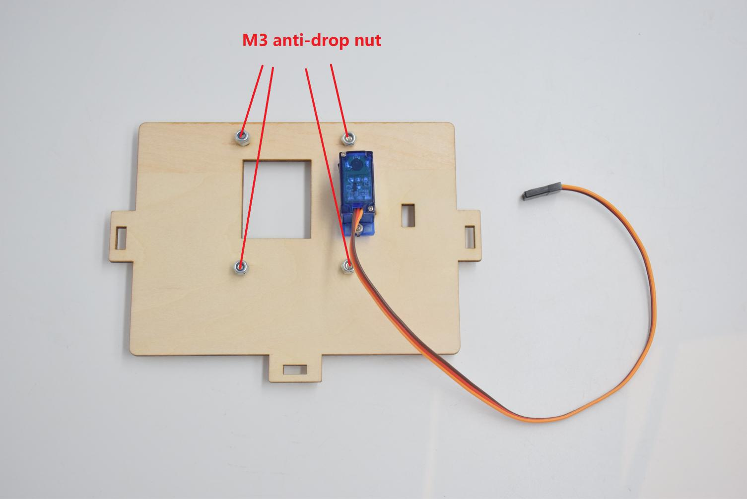

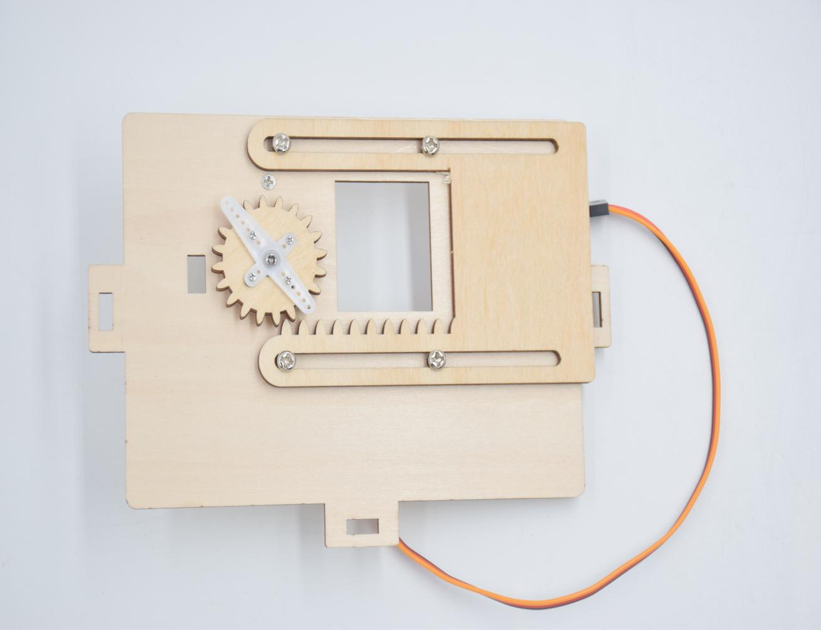

**Step 5: install the sensor of E board**

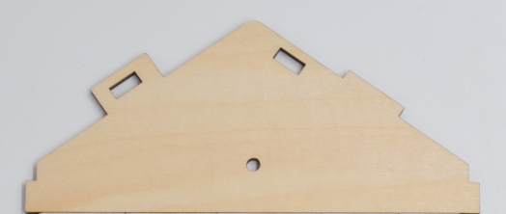

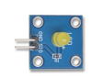x1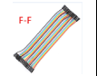x2

M3X10 screw quantity: 1

M3nutquantity:1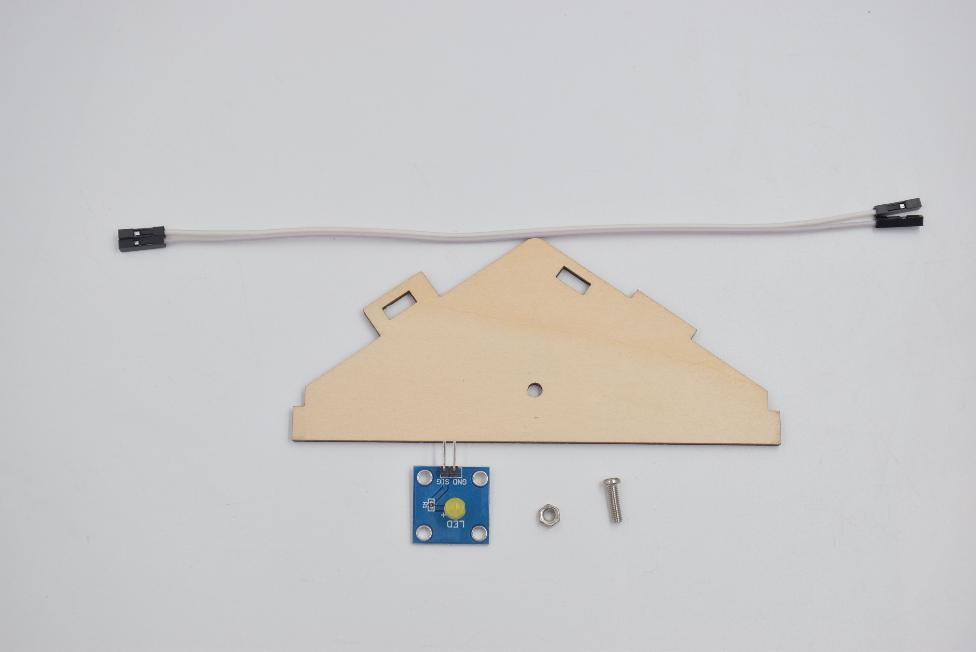

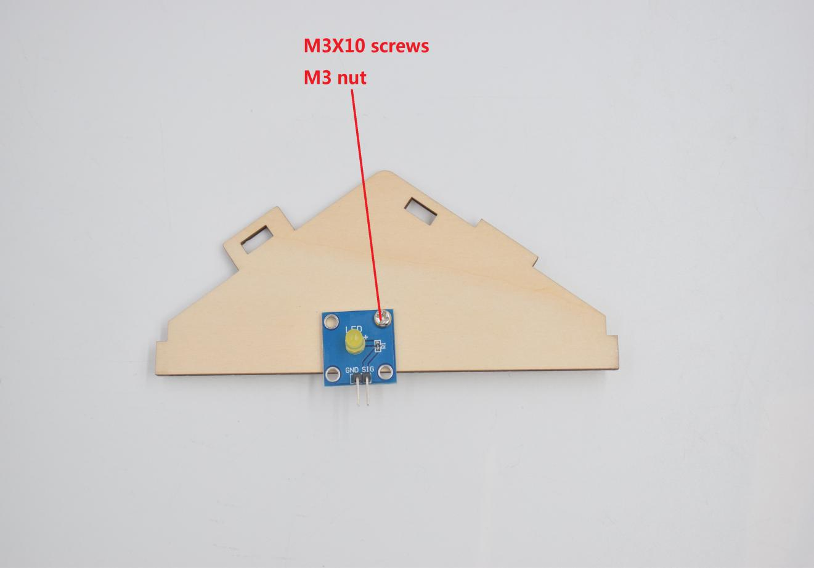

**Step 6: Install control board, sensors and parts of H board**

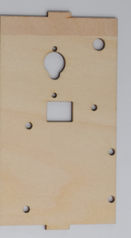x1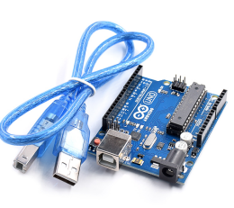x1

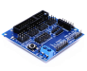x1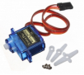x1

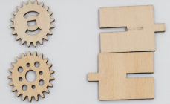X1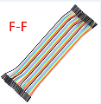x3

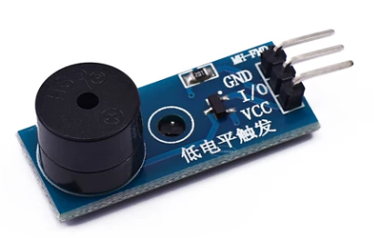x1

M3X10 screw quantity: 1

M3 nut quantity: 1

M2X12 Quantity: 2

M2 nut quantity: 2

M1.2X5 self-tapping screws Quantity: 4

M3x10 Copper Pillar Quantity: 4

M3X7 screw quantity: 8

M2X5 screws in the steering gear bag Quantity: 1

Number of blades in the steering gear bag: 1

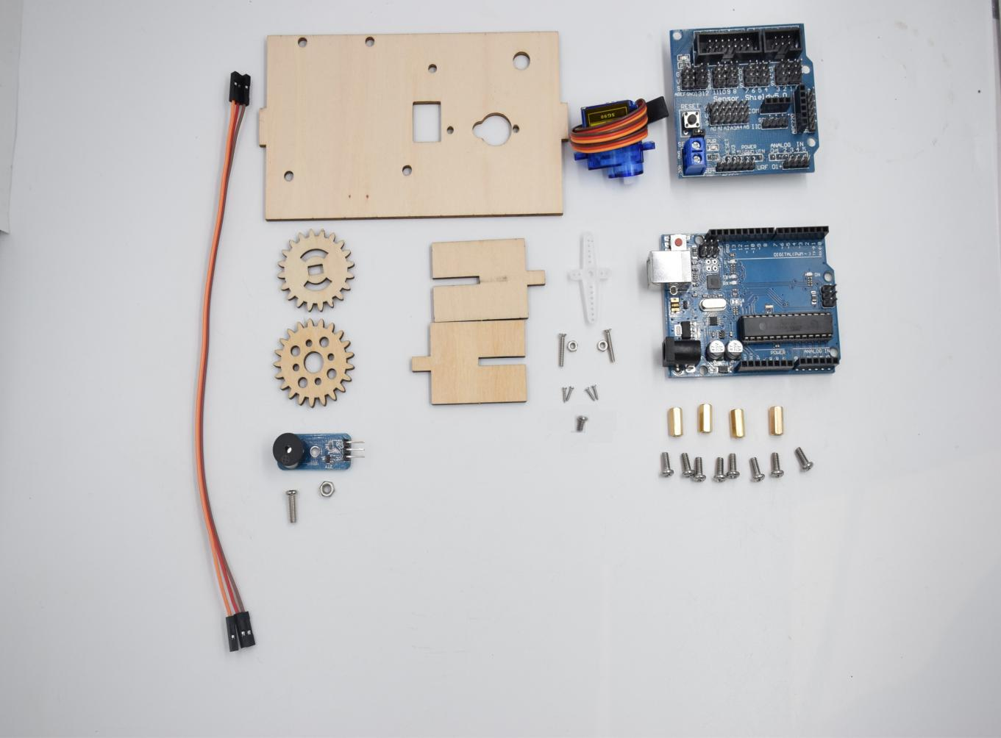

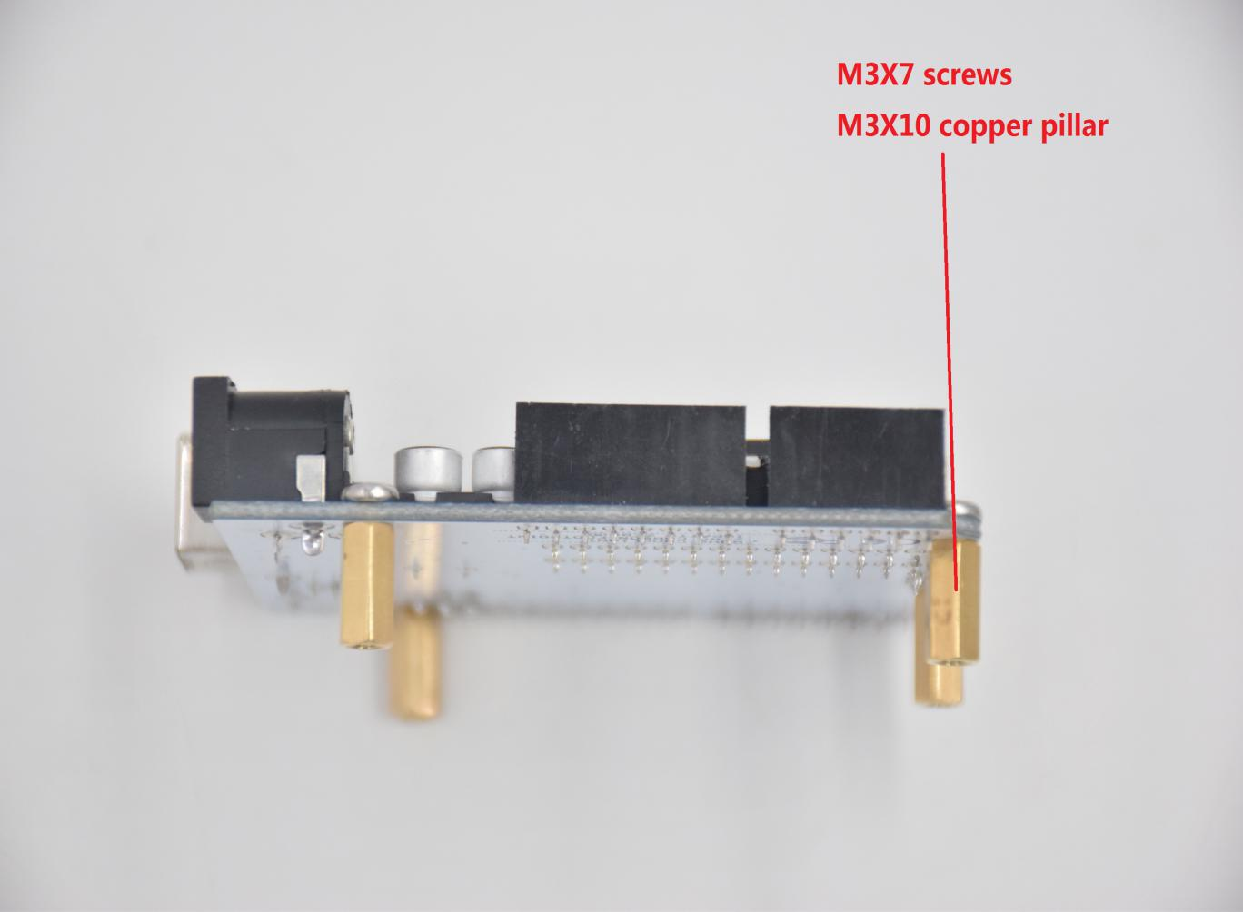

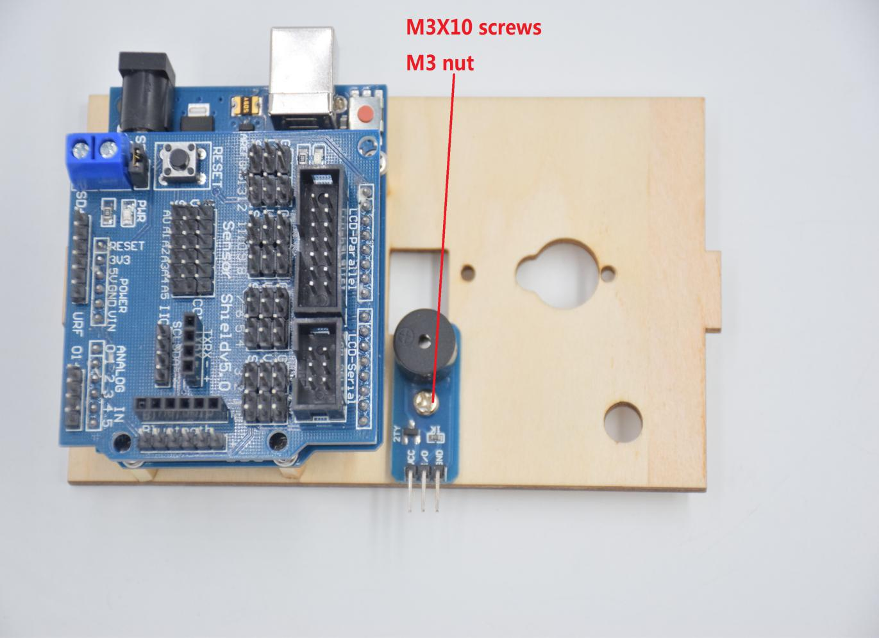

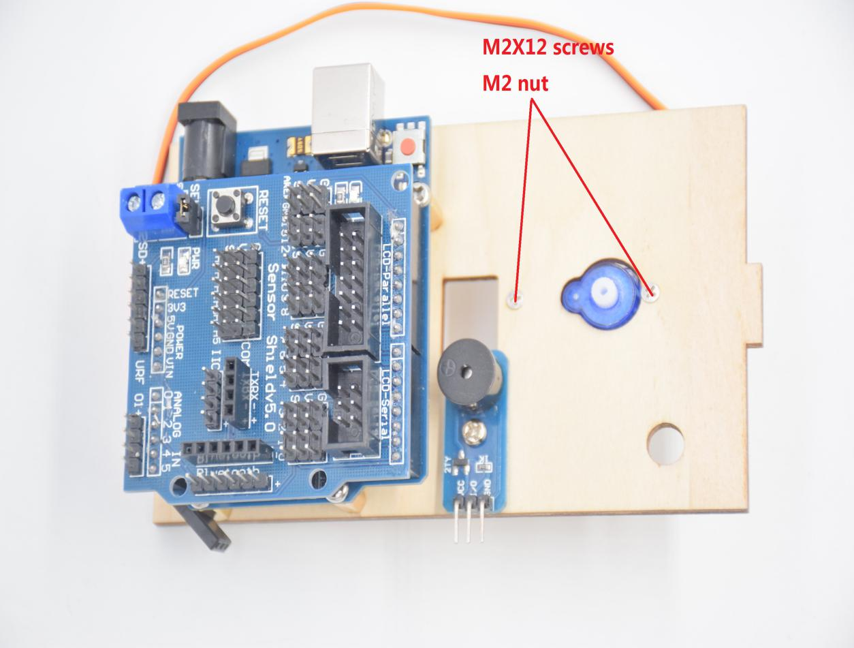

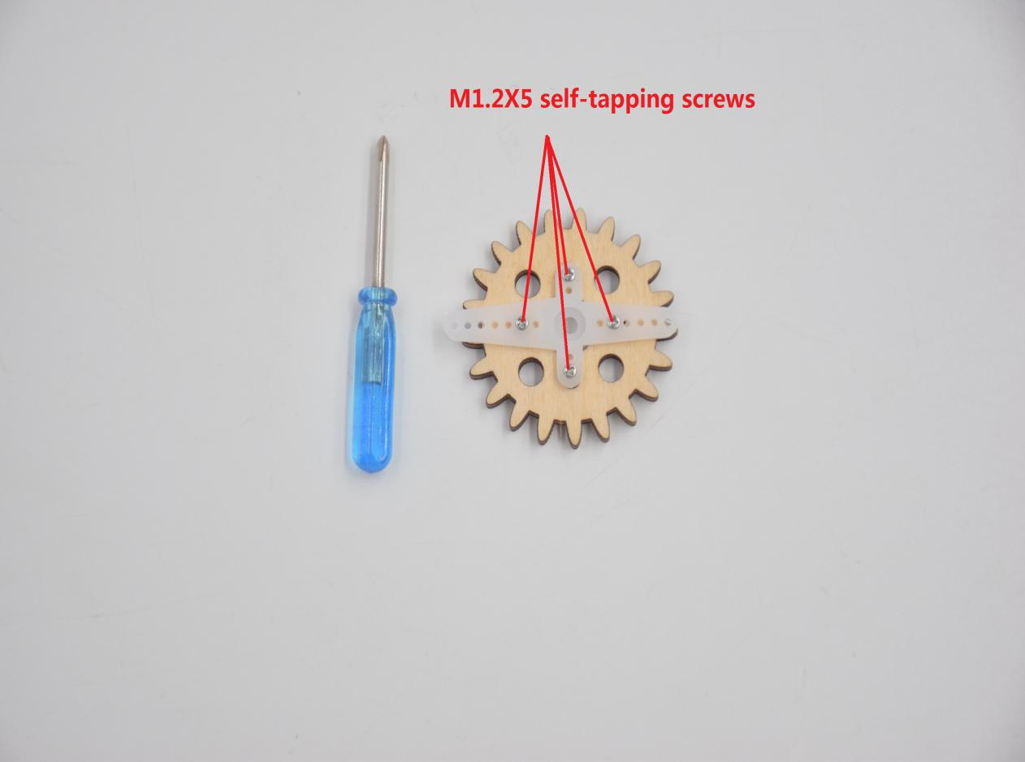

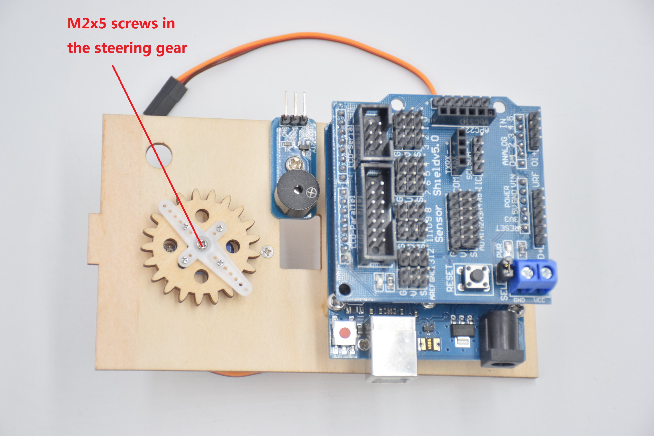

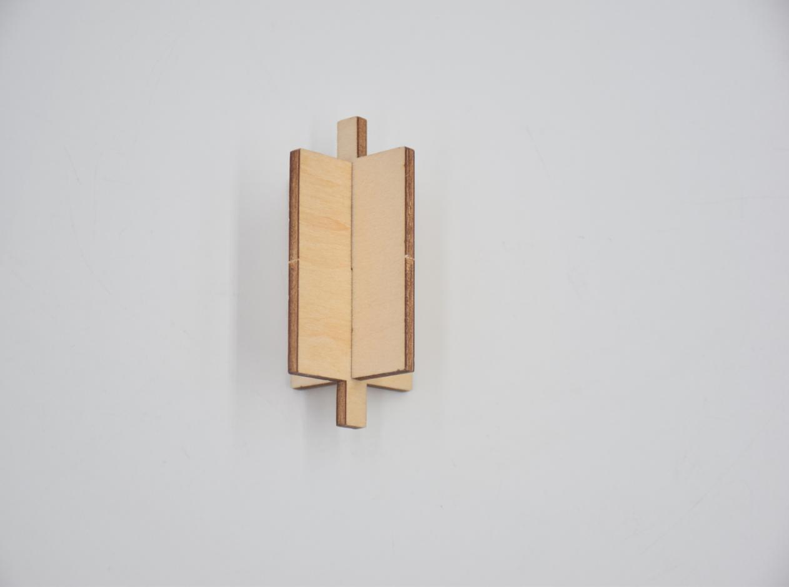

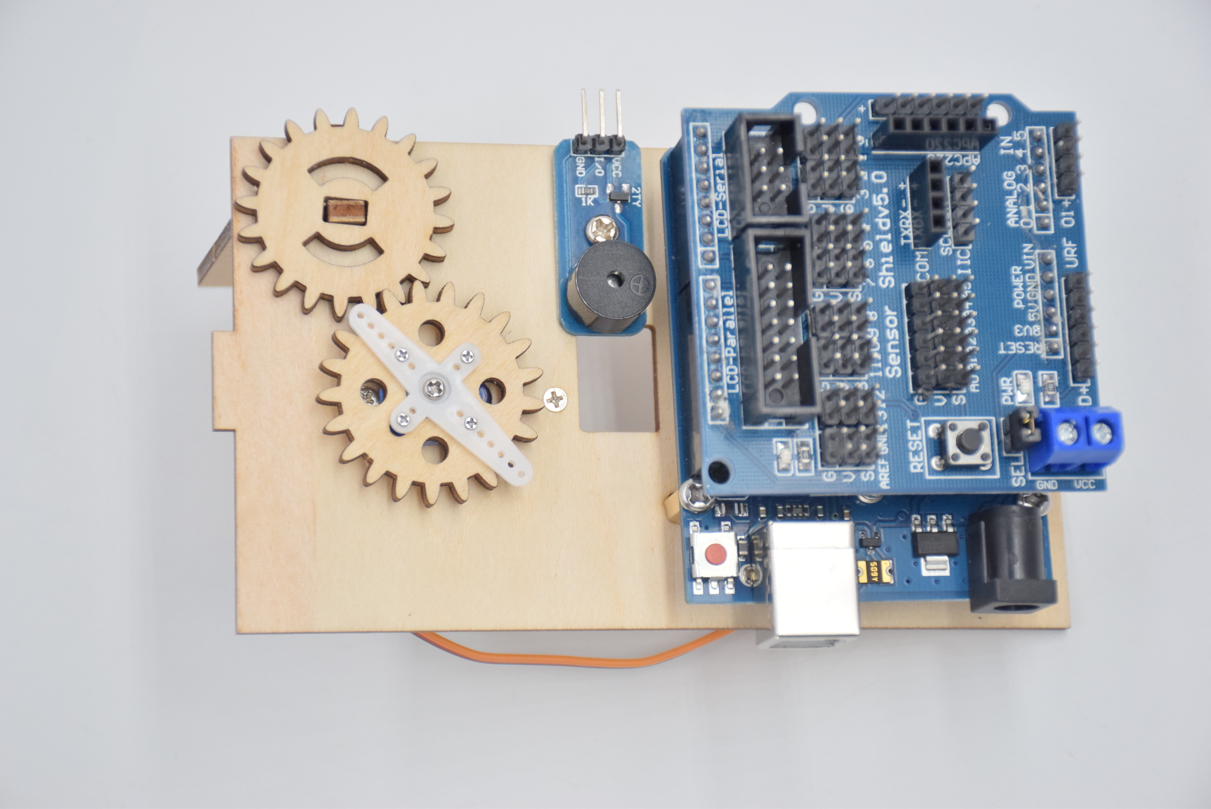

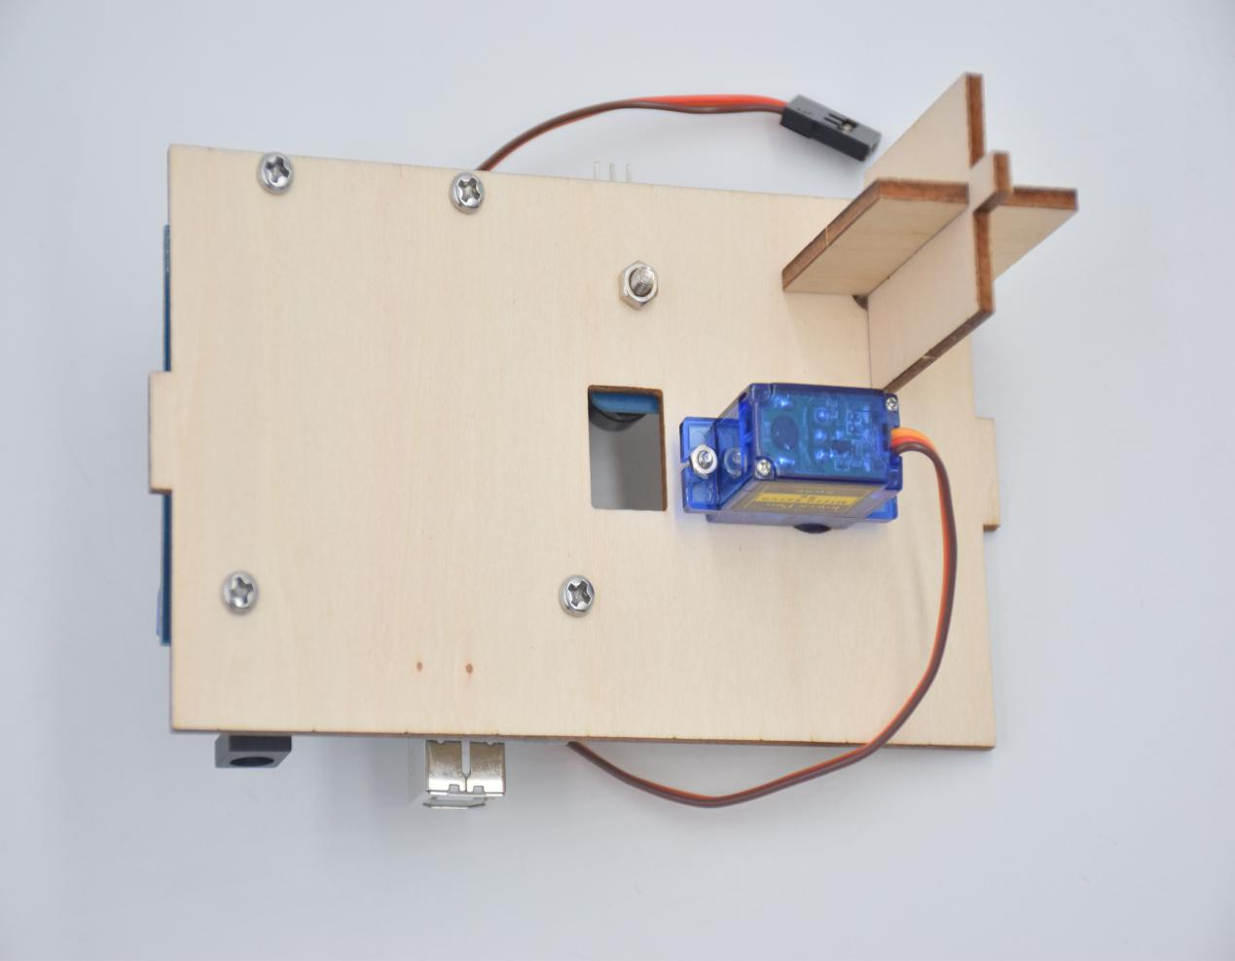

**Step 7: Fix A board and B board together with a “T” bolt.**

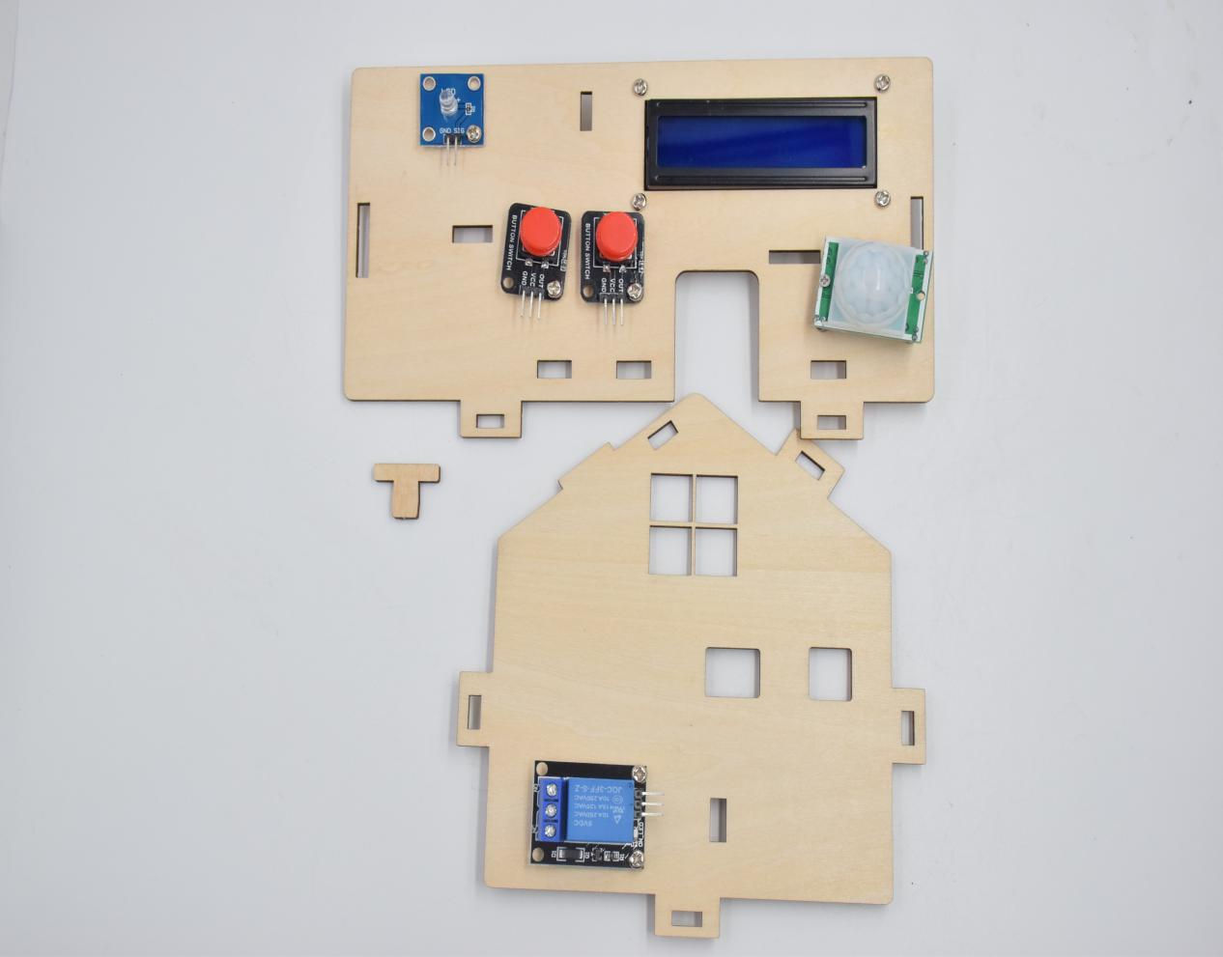

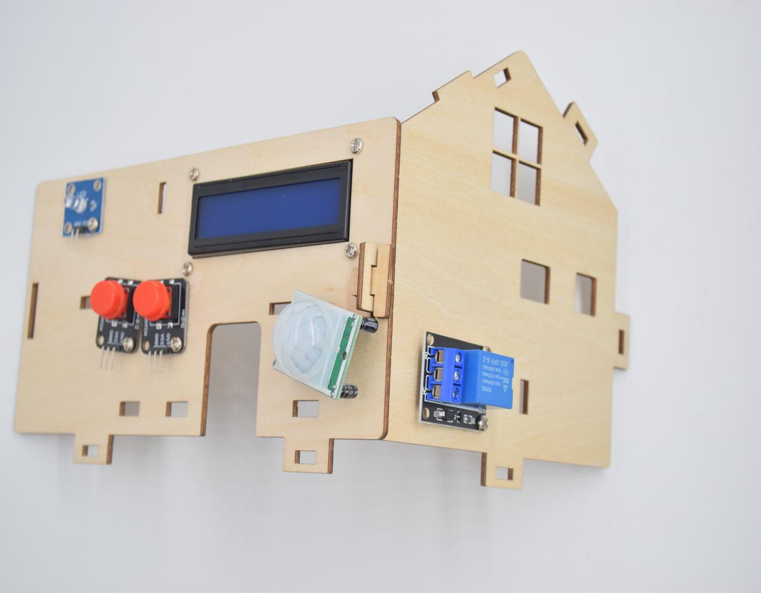

**Step 8: Assemble C board with D board by a “T” type bolt.**

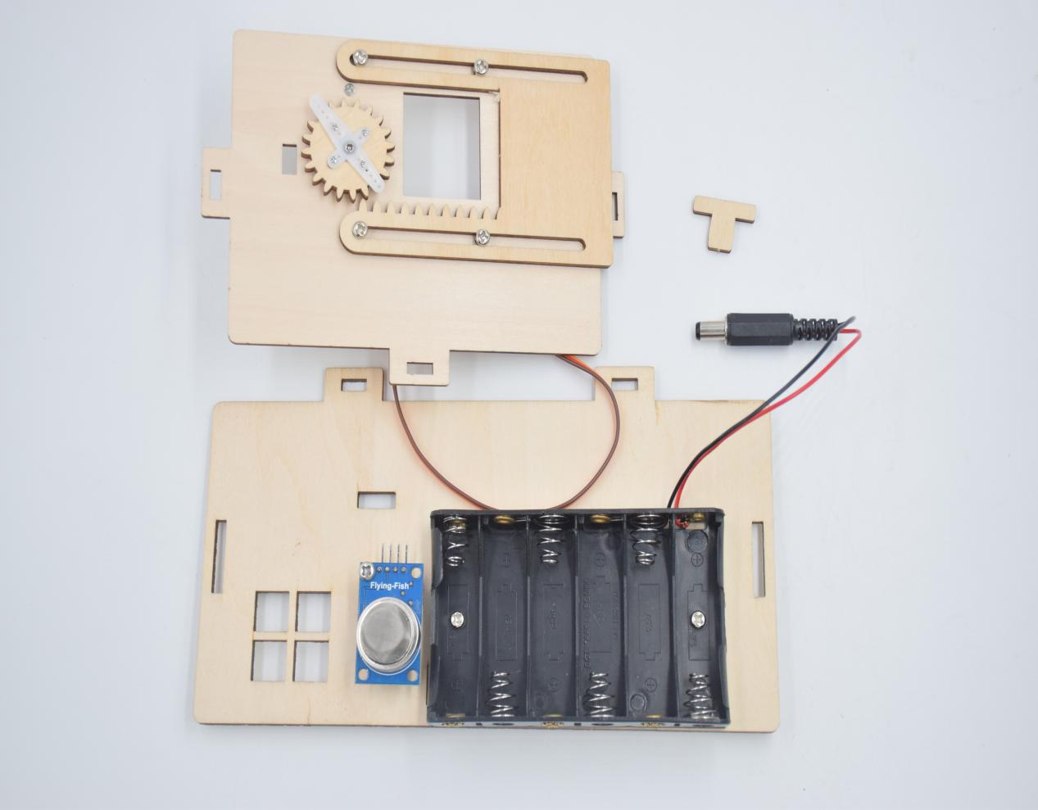

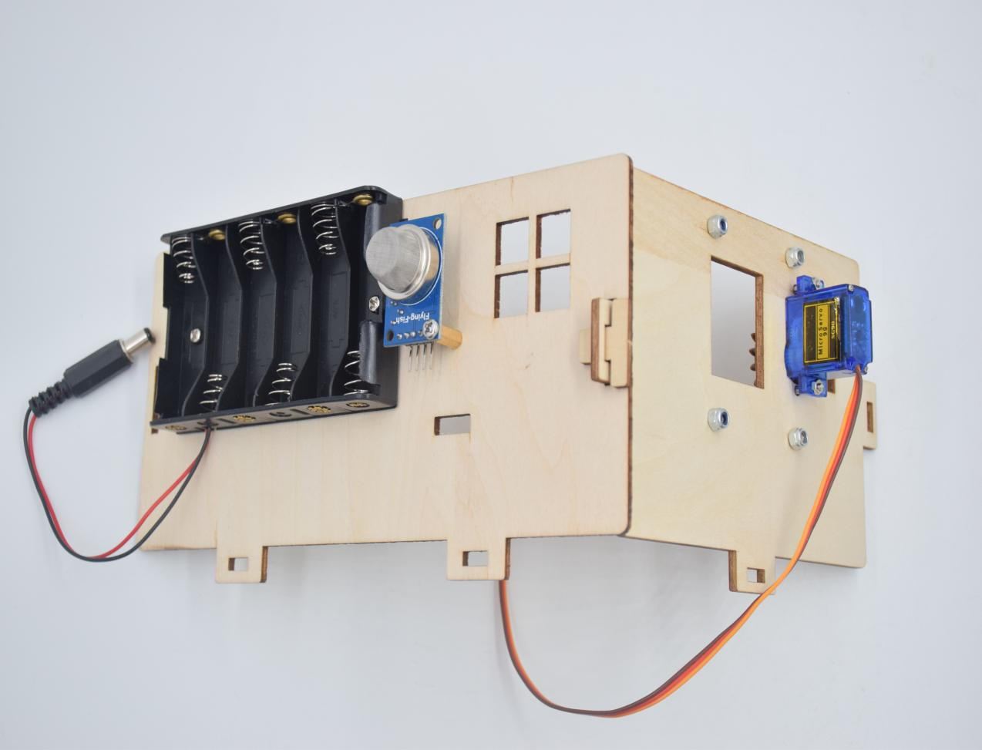

Step 9: Assemble A, B, C, D, E and H board together, then fix them with 2 “T” type bolts.

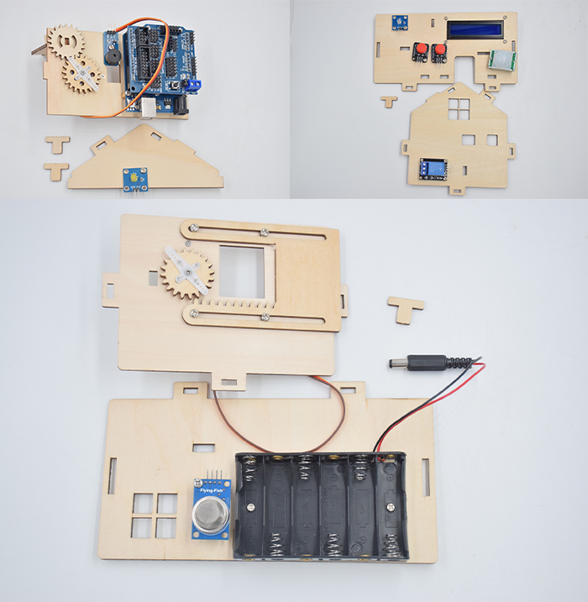

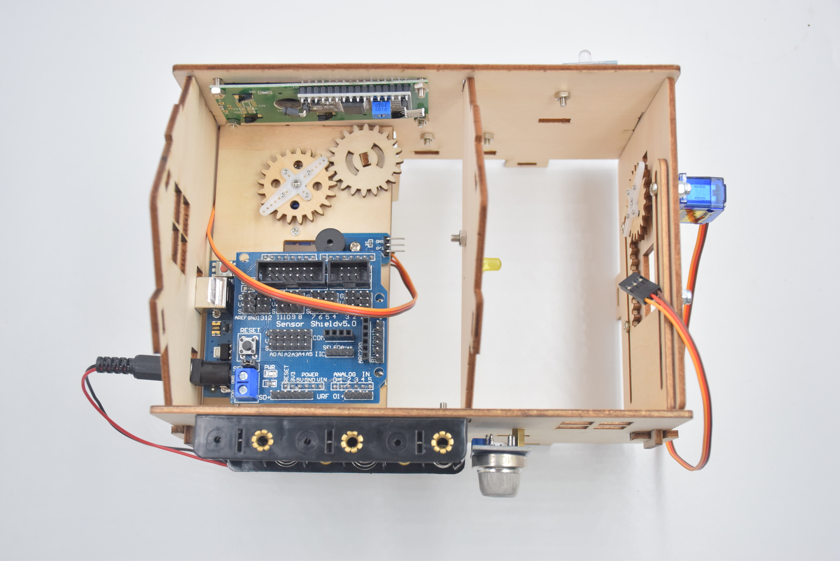

**Step 10: Install the sensor of F board**

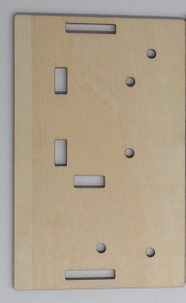X1X10

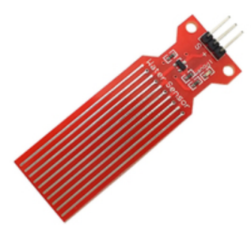x1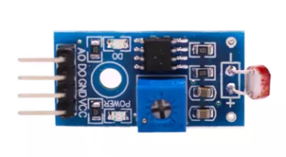x1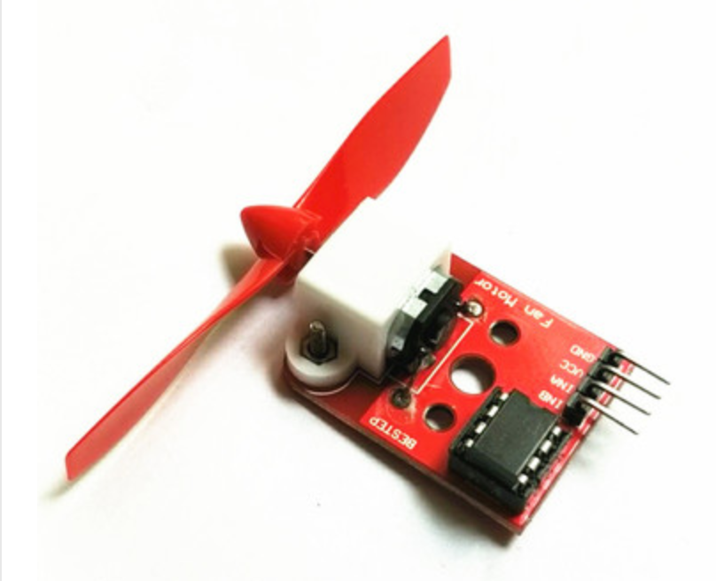X1

M3X10 Screw Quantity: 3

M3 nut quantity: 3

